Authenticating users over the Internet using e-Passports

Dirk-Jan van Dijk and Martijn Oostdijk

Telematica Instituut, P.O.Box 589, 7500AN Enschede

({dirk-jan.vandijk, martijn.oostdijk}@telin.nl)

Abstract
The worldwide introduction of e-passports presents a unique opportunity for the online identity community to implement trustworthy identity providers. The e-passport provides every citizen of the world with a strong authentication token within a global Public Key Infrastructure backed by government administrations. This paper reports on experiments in which e-passports are combined with the user-centric identity management framework Information Card. The resulting implementations were disseminated as open source software.

Introduction
Over the last three years electronically readable travel documents (e-passports) have been introduced in most countries of the world. An e-passport contains an embedded chip with card holder data which allows an automated inspection system (typically operated by border control officials) to read out data from the chip and, more interestingly, to verify its integrity and authenticity. The embedded chip communicates in a contactless way, ensuring that the chip can only be read when it is in proximity of the inspection system.
While there are concerns about the privacy consequences of the introduction [TBD: references], caused by combining contactless communication with privacy sensitive biometric data, it also presents a unique opportunity as it potentially provides every citizen of the world with a strong authentication token within a global Public Key Infrastructure (PKI) backed by government administrations. Moreover, the technical standards which describe how the inspection system verifies the authenticity of e-passports are open and publicly available from the International Civil Aviation Organization (ICAO). Although likely not intended as such by ICAO, e-passports are ideal for authenticating users of third-party online services.
At the same time an entirely different revolution is taking place in the online identity community which places the end-user at the center of the world by relaying all communication between identity providers and service providers through the user’s client. Web 2.0 services are driving this revolution and it is being enabled by user-centric identity management systems such as OpenID and Information Card combined with standardized formalism to express identity claims such as SAML.
This paper describes a prototype user-centric identity solution which uses e-passports. The solution is built on top of open standards and is published as open source software. Users can show aspects of their e-passport to relying parties with the help of an identity provider. The identity provider needs only store minimal information about the user.
The paper is organized as follows: Section 2 is a short introduction to the ICAO standards and describes the various features of the e-passport. Section 3 introduces the Information Card standard. Section 4

Project history
In 2006, shortly before the introduction of the Dutch e-passport, software was developed at Radboud University to test the Dutch implementation of the e-passport. Some of the results were later disseminated as an open source project, JMRTD, hosted at http://jmrtd.org. The software consists of a framework for reading and verifying passports using off-the-shelf hardware.

How passports work
This section provides the reader with a very short introduction to the ICAO standards for e-passports. There are excellent alternative explanations [TBD: references].
- BAC
- Contents of LDS
- Security document (passive authentication)
- Chip authenticity (active authentication)

Identity management
Three models:
- Trust authority (RP trusts IdP ultimately)
- Trust authority by proxy (RP trusts some hardware token issued by IdP)
- Web of trust
Standardization of identity management frameworks is a very active field of research. Over the past couple of years a great deal of attention has been given to new standards such as SAML [TBD: ref], … A relatively new movement within this field focuses on the user the user’s (lack of) control over what aspects of his or her identity are communicated to various parties. Standards such as Information Card (or: InfoCard, for brevity) and OpenID have recently .

TBD: e-passports can be used for defining trustworthy identities on the Internet.

- InfoCard (also known as: Information Card or I-Card) is a standard for browser side user-centric identity management. The user is presented with a selection of various virtual identity cards and picks one when a service provider requires authentication. Microsoft’s Windows Card Space is a closed source implementation of the standard. Several open source initiatives exist: for instance the Higgins project at http://www.eclipse.org/higgins/ and DigitalMe at http://www.bandit-project.org/index.php/Digital_Me.
- OpenID is another standard that enables service providers (relying parties) to delegate authentication to trusted identity providers. This grassroots initiative is currently gaining momentum as big vendors endorse the standard both as identity provider and as relying party. Several open source initiative exist both for setting up identity managers and relying parties: http://wiki.openid.net/Libraries.

Web of trust
Web of trust is peer-to-peer trust. Sometimes: Web 2.0. Reputation based trust. TBD.

CACert.org basically does the same thing that we propose but establishes a distributed network of trust by having users meet in real life and present their (non-machine readable, old fashioned) passport in order to gain trust points. This results in a trustworthy Certificate Authority which typically signs SSL certificates.
Other standards for identity management exist, for instance SAML, Liberty Alliance. InfoCard and OpenID seem to be two of the standards that are gaining momentum as big vendors are endorsing them. Concepts and ideas from the CACert.org initiative could be useful as analogies for the current project. Part of the work is making the correct choice between all these standards.
What InfoCard and OpenID have in common is the role of the user. The user is in control over his/her identity (hence: “user-centric identity management” or Identity 2.0). Combining InfoCards and OpenID is possible (the two standards focus on different aspects of distributed identity management). How authentication of the user is done on the browser side, however, is left abstract at the moment. Our project intends to change this by enabling strong e-passport based authentication.

How we use e-passports for online authentication
All ICAO compliant e-passports include a data group with basic card holder information (name, date of birth, date of expiry of document, document number, gender, nationality).
All countries that issue ICAO compliant e-passports implement a security mechanism called Security Object. The purpose of the Security Object is to ensure the integrity of the data on the passport. The Security Object contains signed hashes of all data that can be read by the inspection system. The signature itself is signed with the issuing country’s private key.
Most countries that issue ICAO compliant e-passports implement a security mechanism called Active Authentication. The purpose of this mechanism is to verify that the chip itself is authentic and not a mere clone of an authentic passport. The card contains a public key which can be read by the inspection system, and a private key which is stored in secure memory. By playing a simple challenge-response protocol the passport can prove possession of the private key and since the Security Object contains a signed hash of the related public key a correct response to the challenge proves that the passport is authentic.
The browser side part of our solution uses both security mechanisms when presented with an e-passport: The information contained in the Security Object proves that the issuer of the passport (the country that once issued an e-passport) is authentic and hence the basic card holder information does indeed correctly identify a citizen of that country (for as far as the service provider trusts that country). Using Active Authentication (in combination with the Security Object) the service provider can be convinced that the authentic e-passport is indeed currently present at the end-user’s contactless card reader and thus that the end-user is likely to be the described citizen.
We propose to create a trustworthy identity solution that allows a user to use their e-passport for authentication at regular web sites or web-services (e.g. for e-government like services). Such a solution may contain a browser plug-in that integrates the software developed in JMRTD with an open source identity selector (perhaps compatible with InfoCard). Additionally, our solution may require the establishment of a central server that acts as an identity provider (perhaps compatible with OpenID).
The implementation depends on properties of the different solutions around. These properties still have to be studied in detail in the initial phase of the project. We expect that our solution with respect to privacy issues (limited disclosure of information) will be a proof of concept solution and will generate opportunities for further research.

Technical Overview
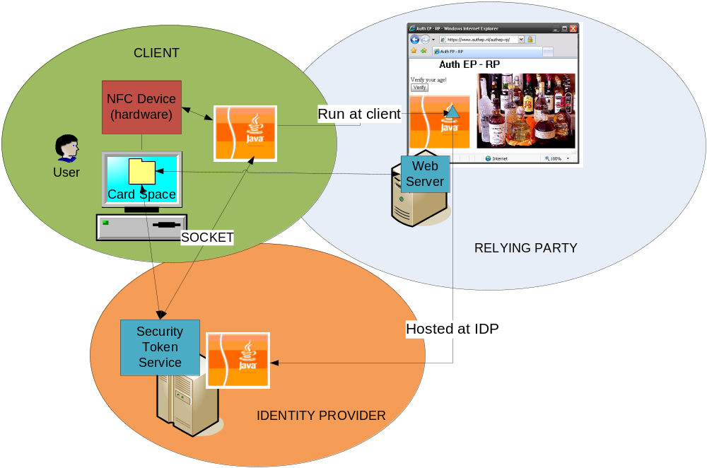
In the AuthEP scenario we have the traditional three parties that are used with CardSpace namely the relying party, identity provider (IdP) and client.
First the user will need to visit the IdP’s website and request a managed card. The managed card will be tied to the user’s passport and therefore the user should supply the BAC data to the IdP. The BAC data will be used later on by the IdP to allow communication with the passport.
After the user has acquired a managed card it can visit a relying party. The difference between a normal CardSpace session and the AuthEP case is an extra step between the client and the IdP after the client has requested a token at the IdP. In this extra step the IdP needs to check if the user has a valid passport and get the user’s details from this passport. In order to achieve this the IdP provides a Java Applet that can communicate with a digital passport. The relying party can link to this applet on its login page to make sure that the client is running it at the moment he’s signing in and requesting a token. The applet will first open a socket connection between the client and IdP. We use this socket connection for any communication between the IdP and the user’s passport. As soon as the client actually requests a token at the IdP, the IdP will look at the provided managed card and send the appropriate BAC data to the passport authenticating the IdP at the passport. The IdP will request the passports public key and security document. With the security document it can check if the public key has been signed by an appropriate government instance. It can then send a challenge to the passport which will prove not that the passport is authentic and not a simple clone. The IdP will request the minimal needed information from the passport to confirm to the token request. The token is send back to the client and from here on the normal CardSpace scenario can continue.

Discussion
A user may not want to share all of the information contained in his or her e-passport with just any service provider. The decision to share a particular item should be left up to the user’s discretion. An example may be a web site that requires a user to show that he or she is at least 18 years of age and is resident of a country whose laws and regulations allow the consumption of the web site’s content. It seems natural that the browser plug-in should generate multiple InfoCards derived from the user’s e-passport.
The ICAO specifications were not explicitly designed to allow this kind of limited disclosure of data. This means that some research is required to assess the feasibility of generating trustworthy attributes based on the information contained in the e-passport.
One outcome of this research may be that a central server is needed which temporarily has access to more information than is strictly needed by the service provider. If a centralized server is necessary, it should be set up to collect and store information on a need-to-know basis. Moreover, the server should be run by an independent party. A question that will need to be answered is to what degree end-users and service providers need to trust such a centralized identity provider:
- in case of service providers: trust with respect to the correctness of information issued about end-users
- in case of end-users: trust with respect to dealing with privacy sensitive data
It may turn out that the privacy problem requires extensive academic research that is beyond the scope of this relatively small practical project for building an open source solution. Telematica Instituut is talking with several academic partners to see if a joint research project is possible.

Acknowledgements
NLnet.

References
Bud P. Bruegger, Detlef Hühnlein, Michael Kreutzer, Towards global eID-Interoperability, TBD

